**Home Work Questions**

# What is Windows Snipping Tool?

Windows 7, 8, 10

WindowKey-R

Type in snippingtool

Launch Snipping Tool

From the New Menu > Choose Rectagular Snip

Click and Drag your mouse from the top left to the bottom right of the area you want to snip

That part of your screen is now displayed in the Snipping Tool window

Choose copy

Go to a Word Document

Choose paste

# Do you want use to screen capture just results or the code too?

Because answers to these home work assignments can easily be found on EBAY, I prefer that you capture enough of the screen to identify the results as yours. For example:

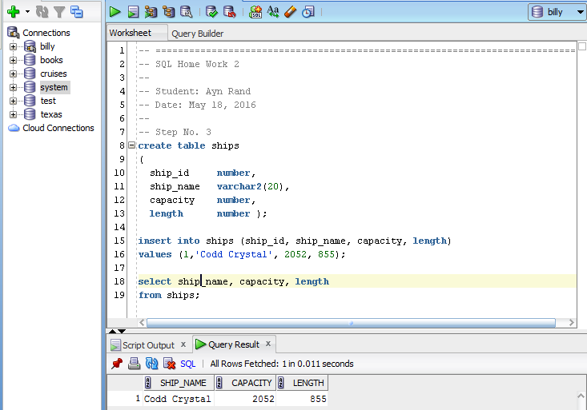

**Your Name**

**Your SQL**

**Your Results**